Name: Pushkar Kumar
Reg_no: 23BCE1634
WEEK-5 [ 50% Implementation of the Project]
Problem statement :
Farmers and consumers often do not know the real journey of agricultural produce from the farm to the market. Middlemen can change prices, hide important information, or mislead farmers and buyers. Because of this, farmers may not get a fair price, and consumers cannot verify the quality or origin of the produce they purchase.
To solve this, we want to build a blockchain-based system that records every step of the produce supply chain in a secure and transparent way. Each time the produce moves from a farmer to a distributor or retailer, the transaction will be stored on the blockchain so no one can change or delete it. Smart contracts will automate the recording process, and customers can scan a QR code on the product to see details like where it was grown, when it was harvested, and how much it cost at each stage.

This system will help farmers get fair prices, reduce fraud, and help consumers trust what they buy. It will be simple to use and can run on low-cost hardware or cloud platforms.
Methodology / Approach:
The development of the Agri Supply Chain Blockchain Platform follows a structured and modular approach to ensure clarity, scalability, and security.

1. Requirement Analysis
Initially, the system requirements were identified by analyzing the problems in traditional agricultural supply chains such as lack of transparency, middlemen interference, and absence of secure transaction tracking.

2. System Design
UML diagrams such as:
- Use Case Diagram
- Class Diagram
- Sequence Diagram
- Activity Diagram
were created to understand system architecture, component interaction, and workflow.

3. Modular Architecture
The system is divided into three main modules:
- Frontend – User Interface for Farmers, Buyers, and Admin.
- Backend – Handles business logic and API communication.
- Blockchain Module – Records and verifies transactions securely.

4. Implementation Strategy
The project follows an incremental development approach:
- First phase: Frontend development
- Second phase: Backend integration
- Third phase: Blockchain connectivity
This structured methodology ensures systematic development and easier testing.

Work Completed So Far (50% Implementation)
At present, approximately 50% of the project implementation has been completed, primarily focusing on the frontend development of the system.

Completed Work:
- Frontend User Interface Development
  - Designed responsive UI for Farmer, Buyer, and Admin.
  - Implemented login and registration pages.
  - Created product listing and auction interface.
  - Developed bid placement screens.
  - Designed shipment tracking interface.
- Basic Navigation & Routing
  - Implemented page routing and navigation between modules.
  - Structured dashboard layouts for different users.
- UI Structure for Auction Process
  - Display of available products.
  - Bid input and submission forms.
  - Status display for auction results.
- Project Structure Setup
  - Organized project folders (frontend, backend, blockchain).
  - Initialized frontend framework and configured dependencies.

ScreenShots:
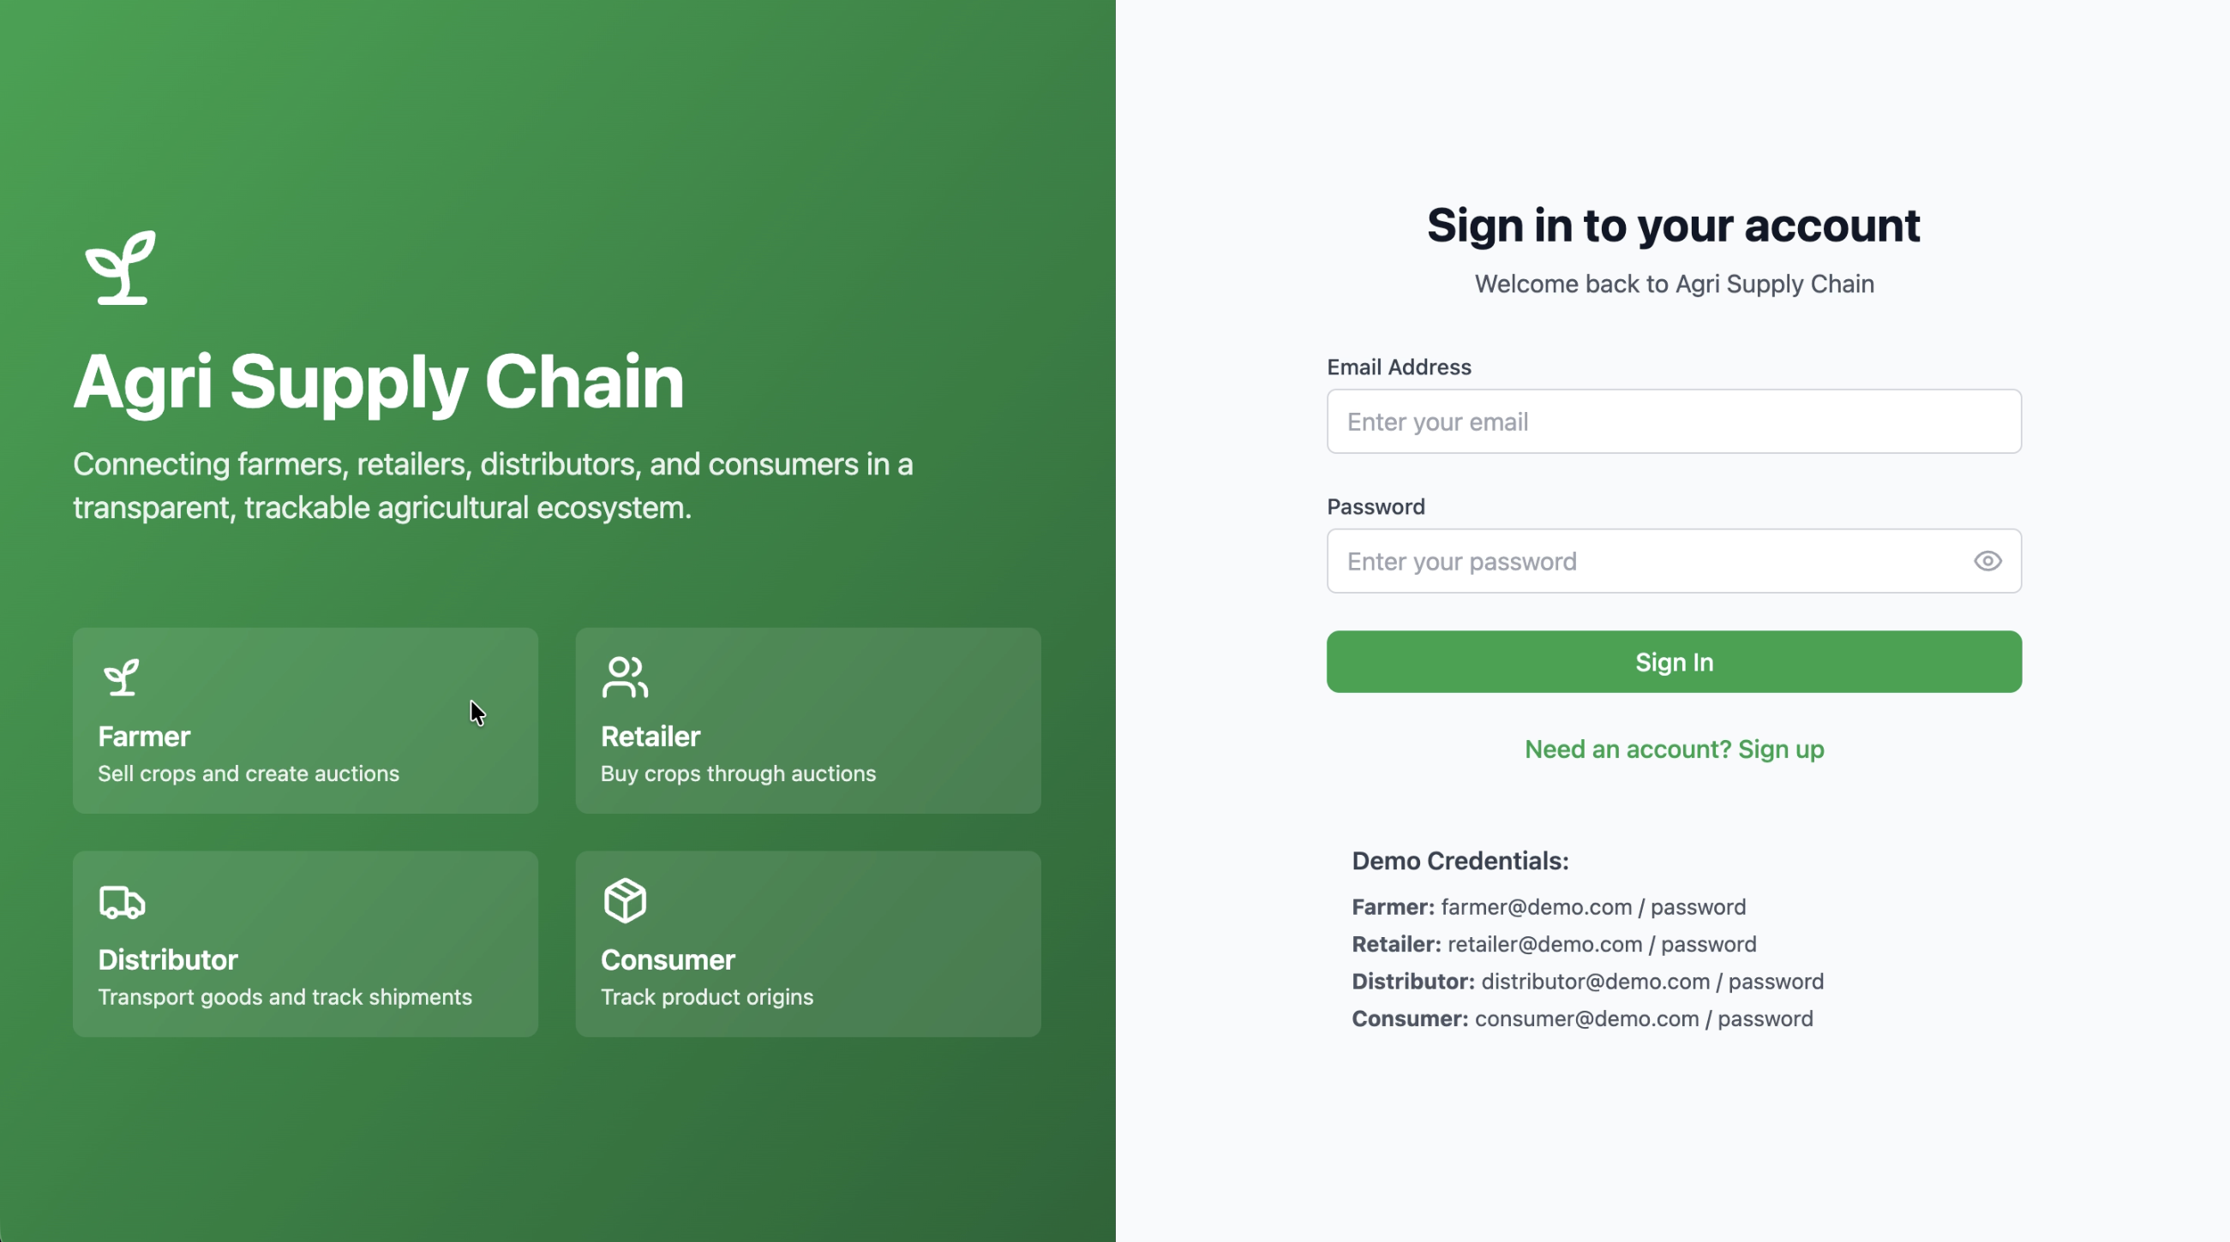
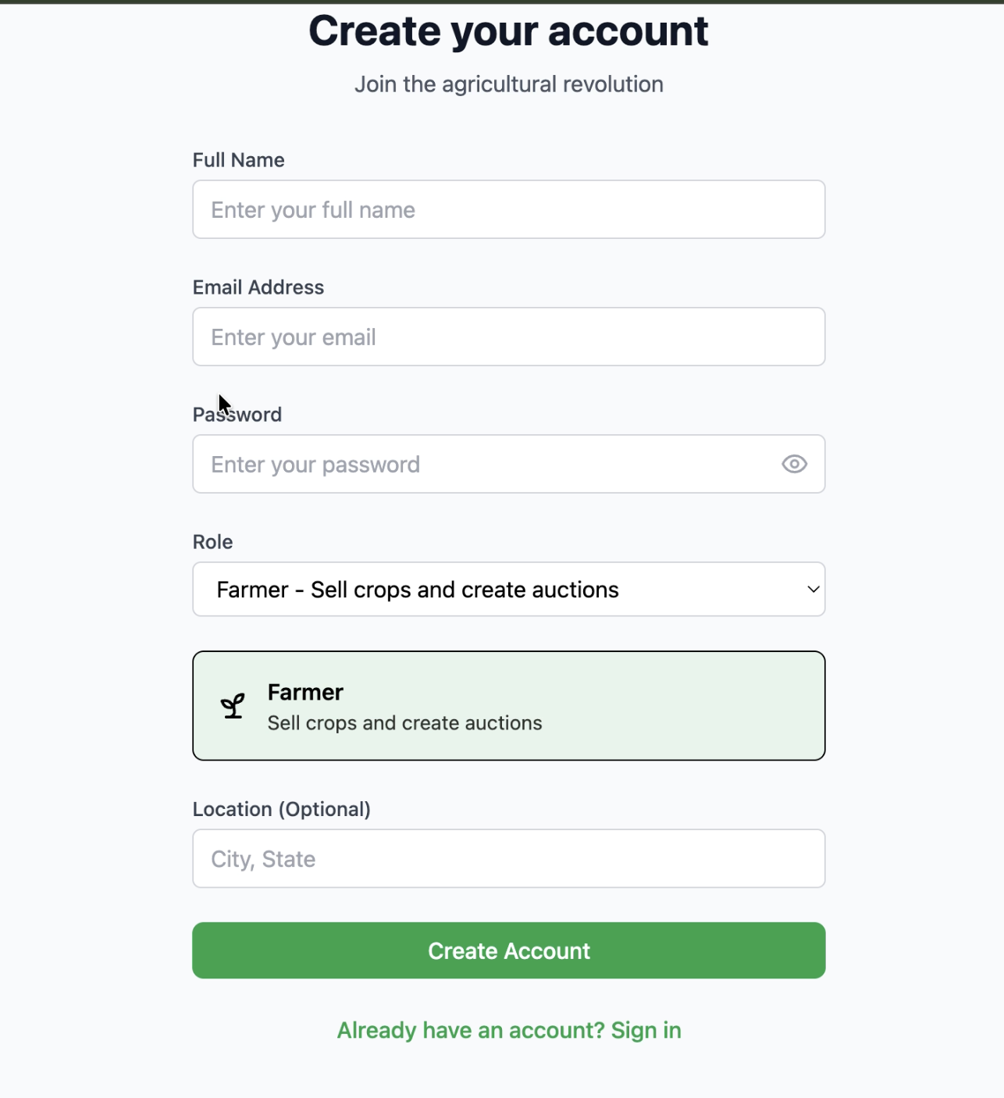
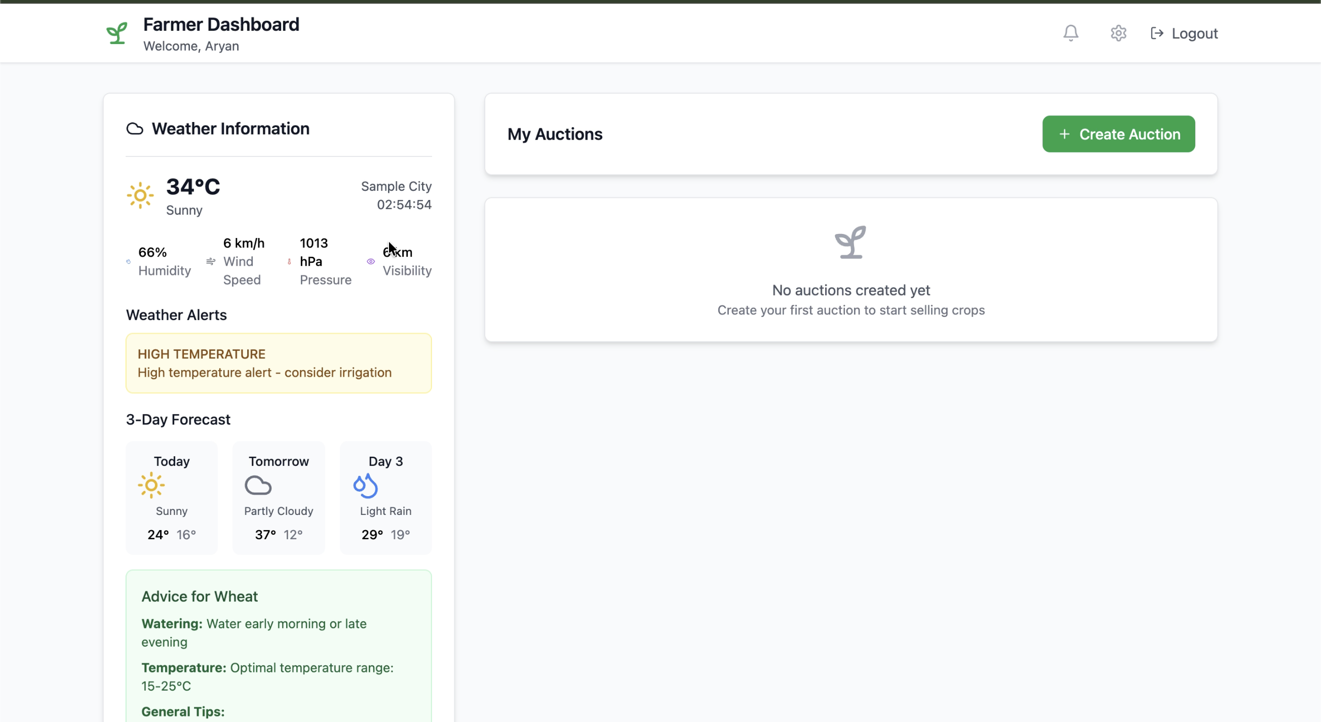
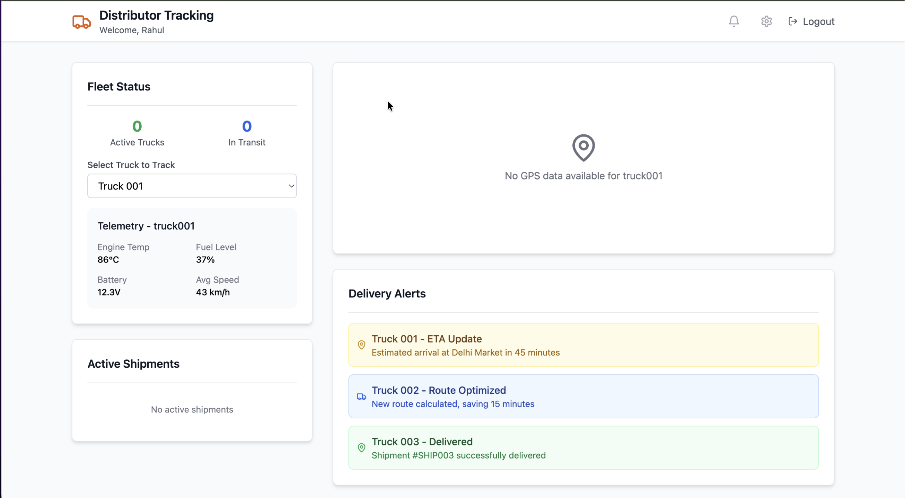
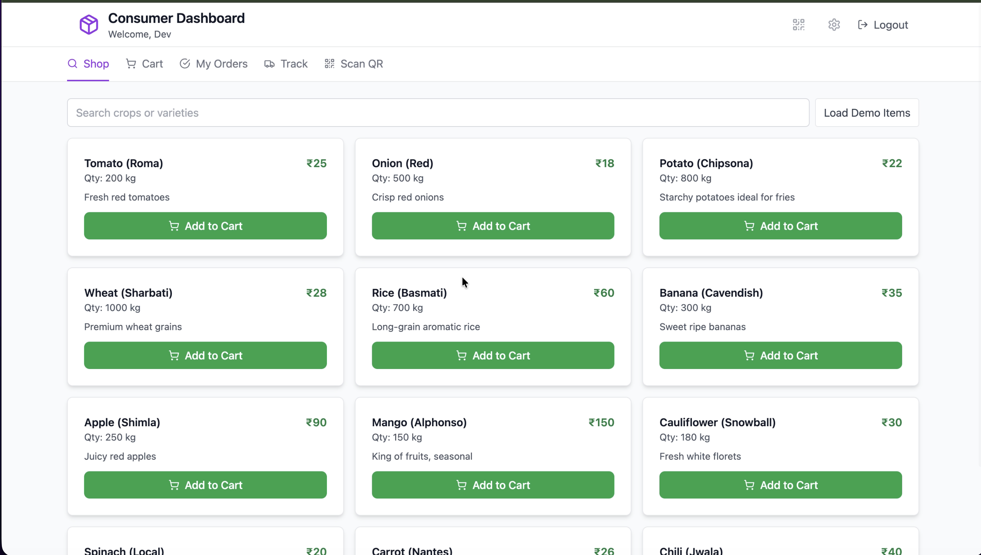
Coding -> Already Uploaded in Github :
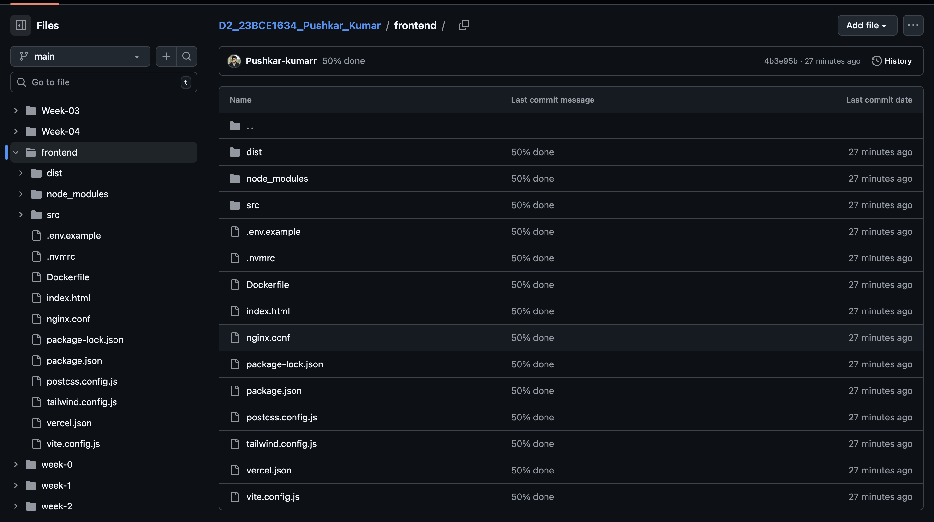
Demo Video Link :
https://drive.google.com/file/d/1l7CI4wg45ZxLXlQSwZ5S4kClxMzdyMwS/view?usp=sharing
Thank You.

